## Basics

Open source

1. sell
2. sell, recipe open
3. free, recipe not open
4. free, open source

Richard Stallman

Linus Torvalds

Three major aspects:

Files & Directories

Users & Groups

Processes

command prompt

command line interpreter

terminal

### commands

1. bultin
2. executable file

### functions

sleep

### system calls

getpid()

getppid()

chmod()

### SHELL

sh

ksh

cshell

tcsh

zsh

fish

bash

(jason bourne)



## Linux File Architecture

inverted tree architecture

/

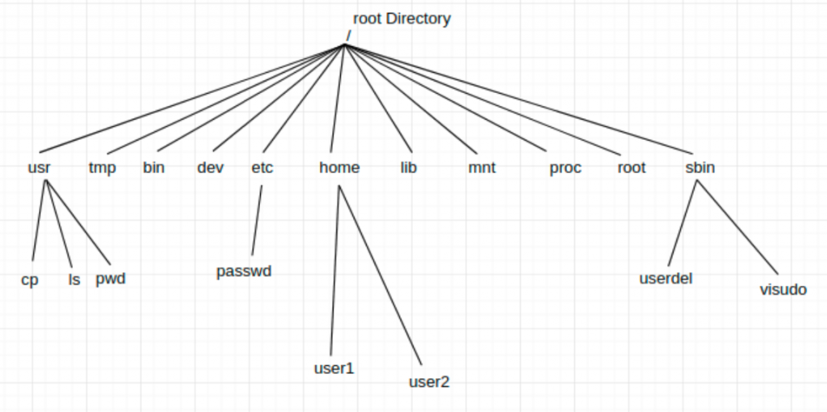

relative path

absolute path

### man

1 commands

2 system calls

3 functions

7 signals

## Files & Folders

mkdir

gedit

vi vim

gvim

atom

Displaying files

cat

nl

less

more

head

tail

mkdir

cp

mv

rm  
rmdir

### vi editor

i insert

esc command mode

command mode:

:w save

:wq save & quit

:q! quit without saving

:w! save as (new file name to be given)

yy copy one line

4yy copy 4 lines

dd cut

delete

p past

u undo

ctrl+u redo

### blocks

0.6L milk

2.2L water

0.4 oil

0.8 petrol

B1 milk

B2 milk

B3 milk

B4 water

B5 water

… …

B1 milk

B2 water

B3 water

B4 water

B5 oil

B6 petrol

33.6L milk

250.2L water

50.4 oil

0.8 petrol

11.3 kb

inode number

inode table

addresses

creation date

last accessed time

last modified time

modes (perms)

links

uid

gid

number of blocks

stat

ext3

ext4

## Users & Groups

modes of a file

training.data

user group others

r w x r w - r - -

1 1 1 1 1 0 1 0 0

7 6 4

got.txt

r w - r w - r - -

6 6 4

r w - r w - r w -

6 6 6

chmod 666 got.txt

chmod +w got.txt

chmod o+w got.txt

r read

w write

x executable

u user (owner)

g group

o others

directories:

r listing names of files

w can not create/delete any file

x cd etc

type of file:

- regular

d directory

l links

b block driver

c char driver

p named pipes (fifos)

s sockets

jane

john

root

abilities of all users

create users & groups

control

chown

chgrp

## Processes

### important terms:

pid

ppid

inode

file descriptor

init

systemd

### ps

-ax all

-ef

-C name of the process

-o output

pid

ppid

%cpu

%mem

time (actual CPU time)

etime (elapsed time)

stime (system time when it wa launched, start time)

cmd name or location

uid

gid

rss (resident set size, non-swapped physical memory)

vsz (virtual mem size)

lwp thread ids

nlwp number of threads

-H hierarchy

-p pid

pstree



### states of a process

S sleep (wait)

R Run

T stop (suspend, pause)

I kernel

Z zombie

D uninterruptible

### background

of a terminal:

jobs

job ids

fg 1

## signals

kill send signals

kill (default SIGTERM)

kill -9 (SIGKILL)

|  |  |  |  |  |  |
| --- | --- | --- | --- | --- | --- |
|  | behaviour | keyboard | handle? |  |  |
| SIGTERM | terminate | no | yes |  |  |
| SIGINT | terminate | ctrl+c | yes |  |  |
| SIGKILL | terminate | no | no | 9 |  |
| SIGSTOP | stop state | ctr+z | no |  |  |
| SIGQUIT | terminate | ctrl+\ | no |  | create a core dump |
| SIGCONT | continue | no | yes |  |  |

## miscellaneous commands and features

### pipe |

### alias

### unalias

### hostname

### uname

### history

### shutdown

### wc

### grep

-n

-i

-v

-w

### links

hard link

symbolic link